RESULTS AND DISCUSSIONS

FOR REGISTER:

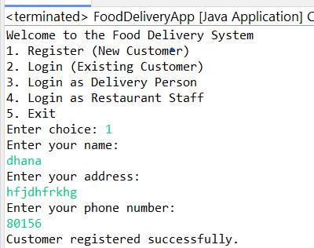 JAVA:

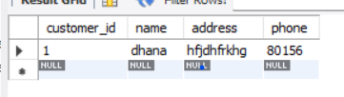SQL:

FIG.5

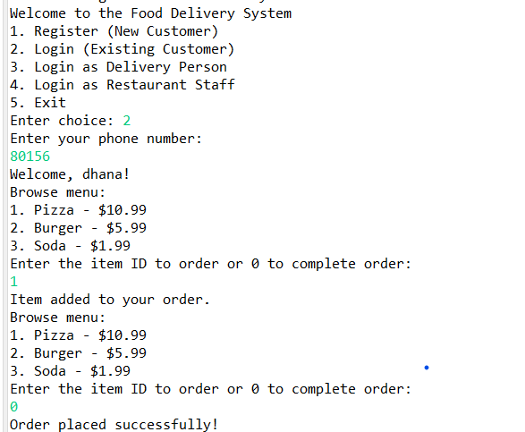FOR LOGIN AND ORDER:

FIG. 6

SQL:

MENU ITEMS:

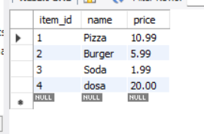

FIG.6.1

ORDER:

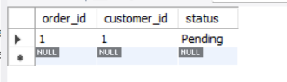

FIG.6.2

ORDER DETAILS:

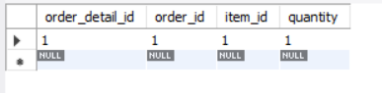

FIG.6.3

FOR DELIVERY MAN(UPDATE STATUS):

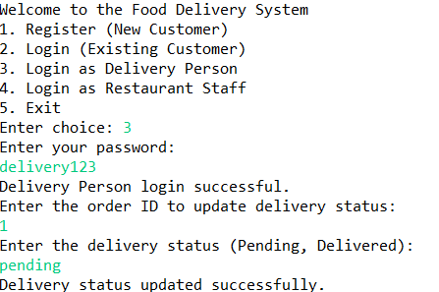

SQL:

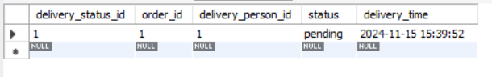

FOR ADMIN(UPDTE MENU ):

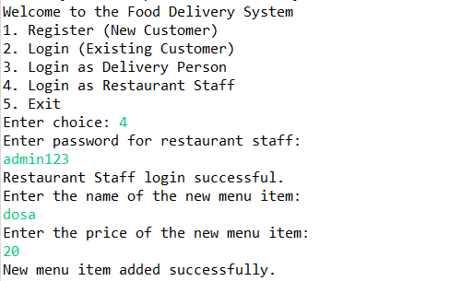

SQL:

